B3.1 Mastery Quiz: Growth and Differentiation
Section A

- Choose the option that would have the fastest rate of diffusion of tea. [1]
Tick ( ) one box.
- Another tea bag being added to a warm cup of tea | 
- A tea bag being added to cold water
- A tea bag being added to hot water

- Choose an example of a prokaryotic cell. [1]
Tick ( ) one box.
- Animal cell
- Plant cell
- Bacterial cell

- Eukaryotic cells have genetic material … [1]
Tick ( ) one box.
- contained in a nucleus.
- free in the cytoplasm.
- organised into plasmids and a loop.

- An embryonic stem cell can differentiate into all types of cell and is taken from … [1]
Tick ( ) one box.
- a developing embryo.
- adult bone marrow.
- a fertilised egg cell.

- When using a light microscope you should … [1]
Tick ( ) one box.
- ensure that the objective lens is touching the slide.
- not put your eye too close to the objective lens.
- use the lowest power objective lens first.

- An empty beaker had a mass of 200 g.

Water was added to the beaker and the mass increased to 250 g.

Calculate the percentage increase in mass. [1]
Tick ( ) one box.
- 80%
- 25%
- 20%

- Active transport is the movement of particles from … [1]
Tick ( ) one box.
- a low concentration to a high concentration, using energy.
- a high concentration to a low concentration, using energy.
- a low concentration to a high concentration, without energy.
- a high concentration to a low concentration, without energy.

- A cube of potato was placed in a beaker of water.
Choose how the mass of the cube of potato changed after a day. [1]
Tick ( ) one box.
- No change in mass
- Increase in mass
- Decrease in mass

- Choose the only correct statement about surface area to volume ratio. [1]
Tick ( ) one box.
- Single-celled organisms are small and therefore have a large surface area to volume ratio
- As organisms get larger, their surface area to volume ratio increases
- The smaller the surface area to volume ratio, the faster the rate of diffusion

- Below shows an image from a light microscope.
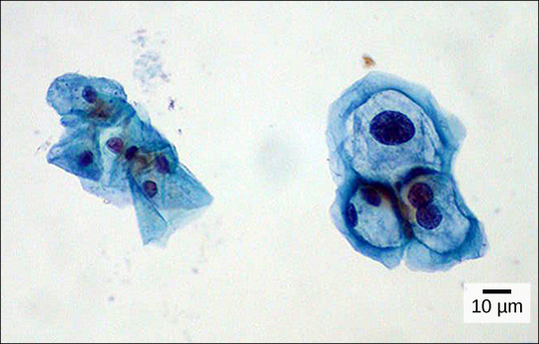
The length of the scale bar is 1 cm.
- Calculate the magnification used. [1]
Tick ( ) one box.
- 0.1
- 100
- 1000

- A scientist wanted to observe the shape of ribosomes in these cells.
The scientist had to use an electron microscope for this because … [1]
Tick ( ) one box.
- it uses electrons instead of light to see the specimen.
- it has a greater magnifying power than a light microscope.
- it has a lower resolution than a light microscope

- Urea is a waste product that diffuses from the liver into blood. This means that the concentration of urea in the liver is … [1]
Tick ( ) one box.
- greater than in blood.
- less than in blood.
- the same as in blood.

- Choose the value that is equal to 41 μm. [1]
Tick ( ) one box.
- 4.1 x 10 ⁻³ m
- 4.1 x 10 ⁻⁵ m
- 4.1 x 10 ⁻⁶ m

- There are 5 bacterial cells in a sample.

Calculate how many bacterial cells are in the sample after 3 cell divisions. [1]
Tick ( ) one box.
- 8
- 15
- 40

- Choose the best description of aseptic technique. [1]

Tick ( ) one box.
- Methods used when working with microorganism, so that surfaces are kept sterile and microorganisms can be grown safely
- When an inoculating loop is sterilized using a Bunsen burner to transfer bacteria
- How a Petri dish is prepared to grow a specific type of bacteria that is found on a particular surface
Section B
- Define osmosis.
_________________________________________________________________________________
_________________________________________________________________________________

- Lifestyle risk factors for cancer include poor diet, lack of exercise, smoking, UV exposure.
Explain what is meant by the term ‘lifestyle risk factors’.
_________________________________________________________________________________
_________________________________________________________________________________

- Describe the stages of the cell cycle.
_________________________________________________________________________________
_________________________________________________________________________________
_________________________________________________________________________________
_________________________________________________________________________________
_________________________________________________________________________________
_________________________________________________________________________________

PLEASE TURN OVER FOR QUESTION 4

- A student investigated osmosis in carrot tissue by placing a piece of carrot in test tubes containing different concentrations of sucrose solution.

The percentage change in mass was calculated and the results shown in the table below.

Complete the graph below using data shown in the results table.

Sucrose solution concentration (g/dm³) | Percentage change in carrot mass (%)
0.0 | 16.1
0.2 | 11.2
0.4 | 3.6
0.6 | - 4.5


Percentage change in carrot mass (%)
0
- 5
5
10
15
20

